VM Ware network contains following machines:
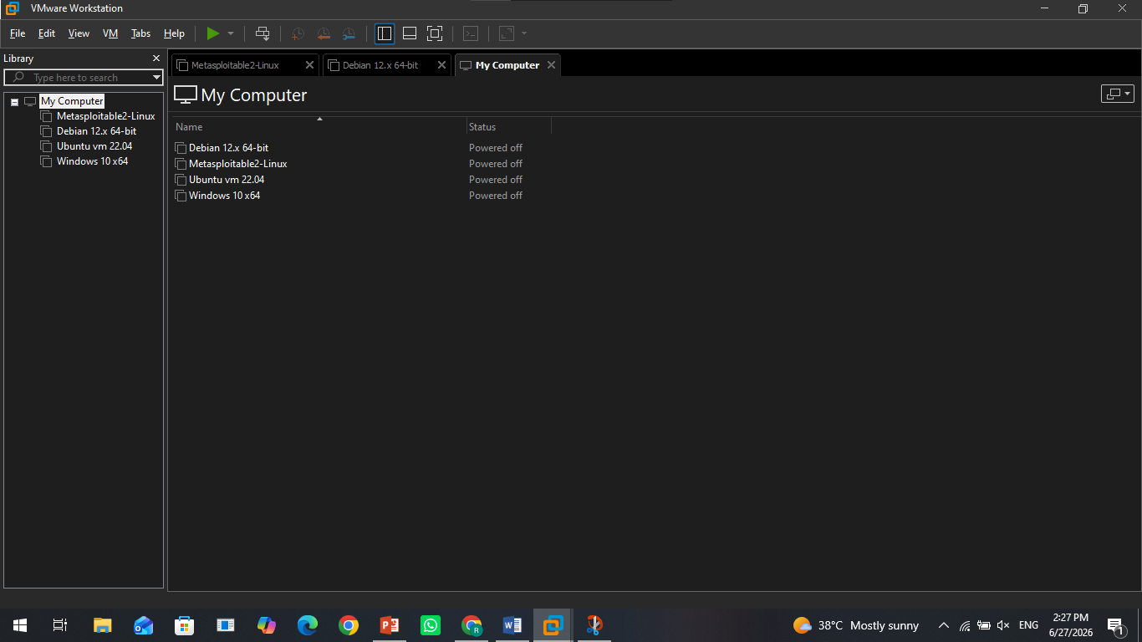
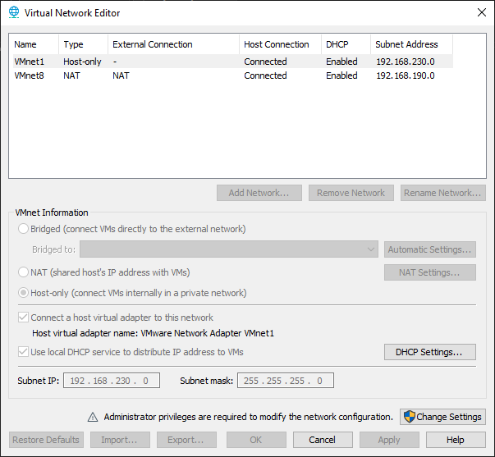
Attacker’s info:
Use commands (hostname, hostname –I, cat /etc/os-release)
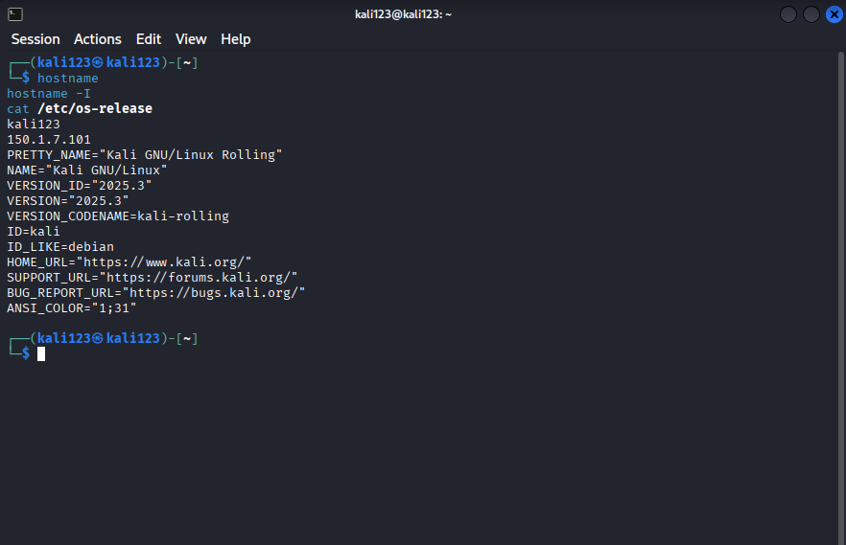
Target info (metasploitable 2)
Use commands (hostname, ifconfig, uname -a)
